**DAILY ONLINE ACTIVITIES SUMMARY**

|  |  |  |  |  |  |  |  |  |
| --- | --- | --- | --- | --- | --- | --- | --- | --- |
| **Date:** | 03-06-2020 | | | | | **Name:** | K S Prajwal | |
| **Sem & Sec** | Vi A sec | | | | | **USN:** | 4AL18CS032 | |
| **Online Test Summary** | | | | | | | | |
| **Subject** | | Object Oriented Concepts | | | | | | |
| **Max. Marks** | | 30 | | **Score** | | | 14 | |
| **Certification Course Summary** | | | | | | | | |
| **Course** | **Python and Django Full Stack Web Developer Bootcamp** | | | | | | | |
| **Certificate Provider** | | | Udemy | | **Duration** | | | **3 hr** |
| **Coding Challenges** | | | | | | | | |
| **Problem Statement:** **:** 1. program to find Last Digit of a^b  2. Largest of two possible digit swaps | | | | | | | | |
| **Status:** completed | | | | | | | | |
| **Uploaded the report in Github** | | | | | yes | | | |
| **If yes Repository name** | | | | | <https://github.com/alvas-education-foundation/KS_Prajwal> | | | |
| **Uploaded the report in slack** | | | | | yes | | | |

Online Test Details: (Attach the snapshot and briefly write the report for the same)

Certification Course Details: (Attach the snapshot and briefly write the report for the same)

Coding Challenges Details: (Attach the snapshot and briefly write the report for the same)

**Online Test Details:**

The online test was from module 2 and 3 which was about introduction to java, classes, inheritance and exception handling. There were 30 questions and the duration was 45 minutes. The questions were optimal and were easy. The score that I got in the test is 14/30.

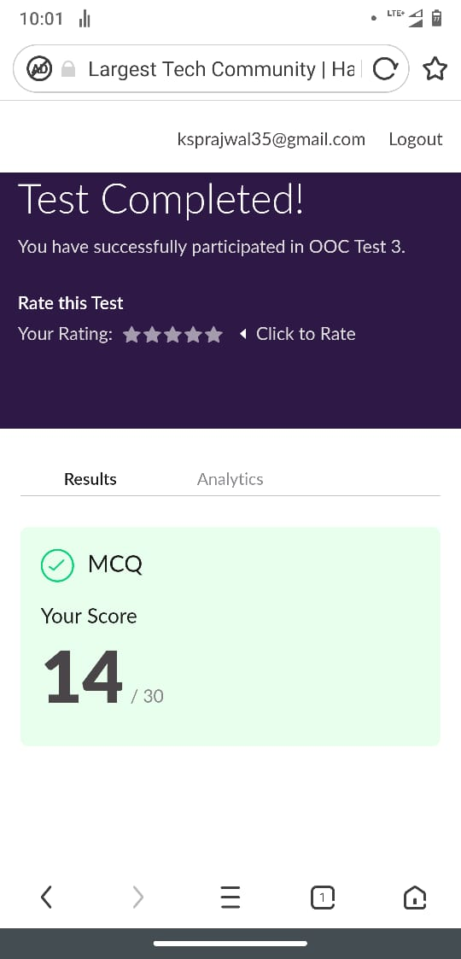

Snapshot of certification course:

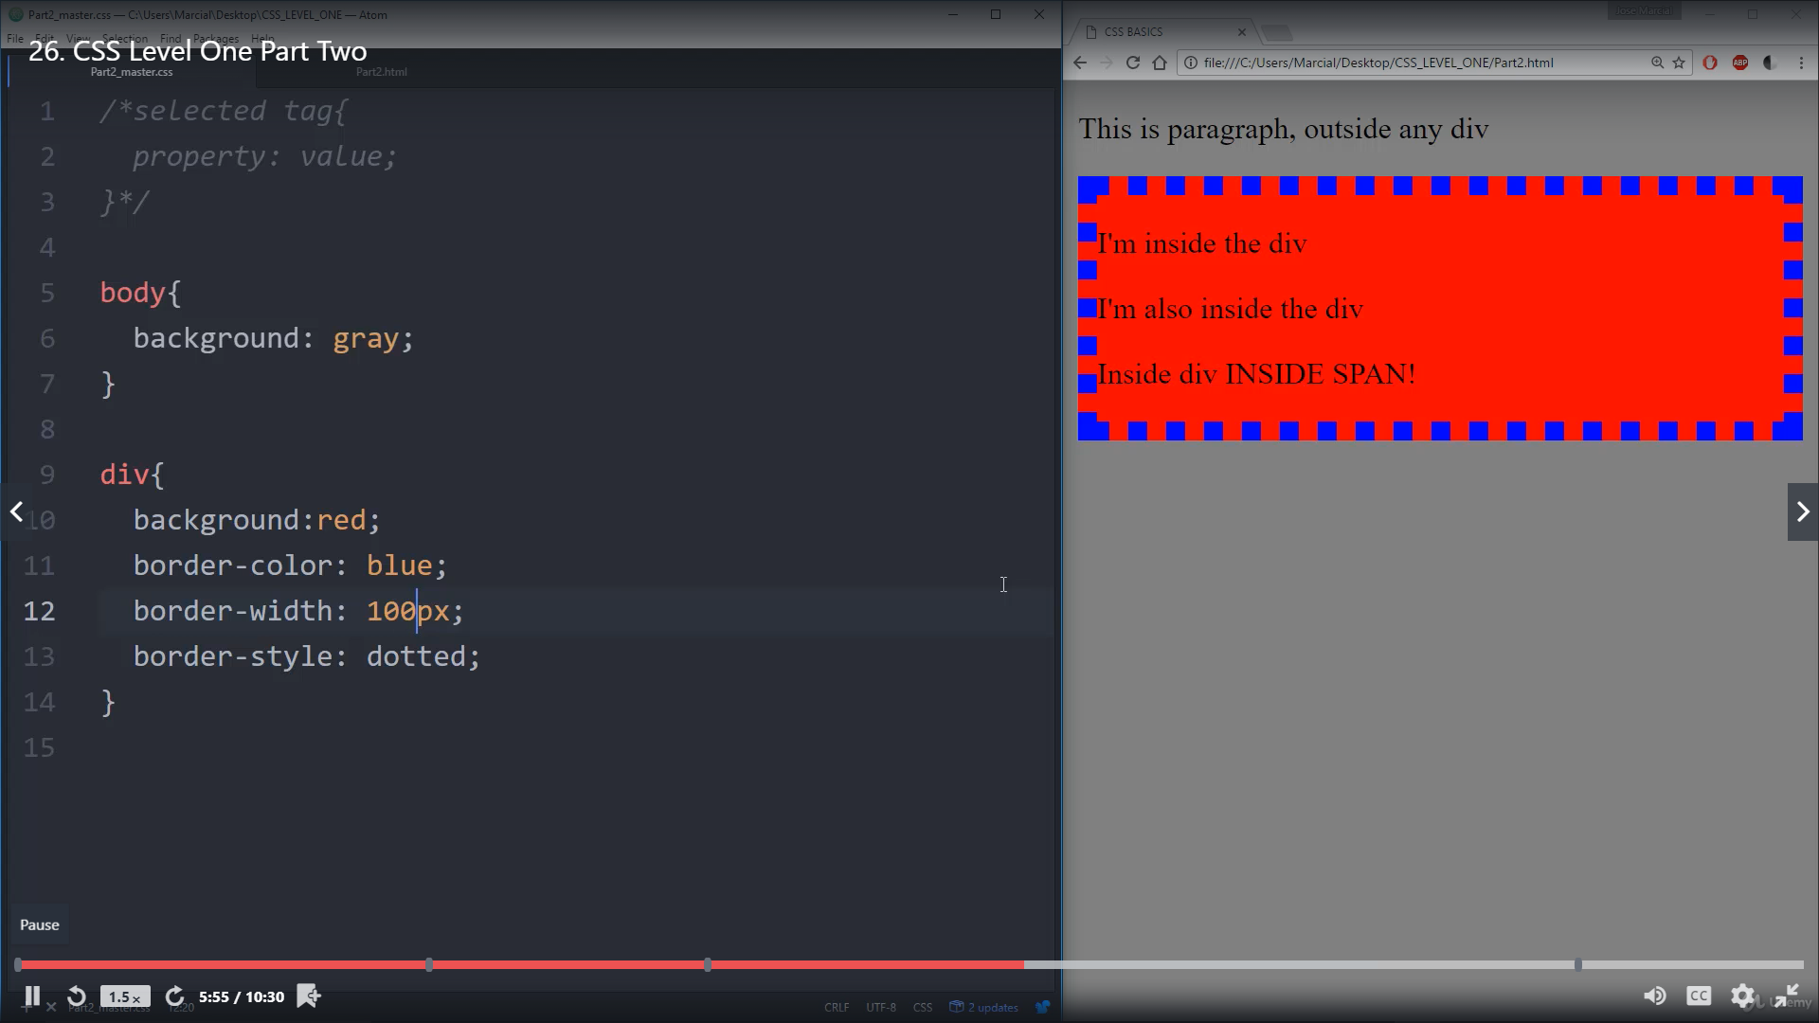

This section was about the CSS how to use it on class tag and id, and also it introduced the different properties of styling

**Online coding:**

Problem 1: (using Java) program to find Last Digit of a^b (a to the power b) for Large Numbers

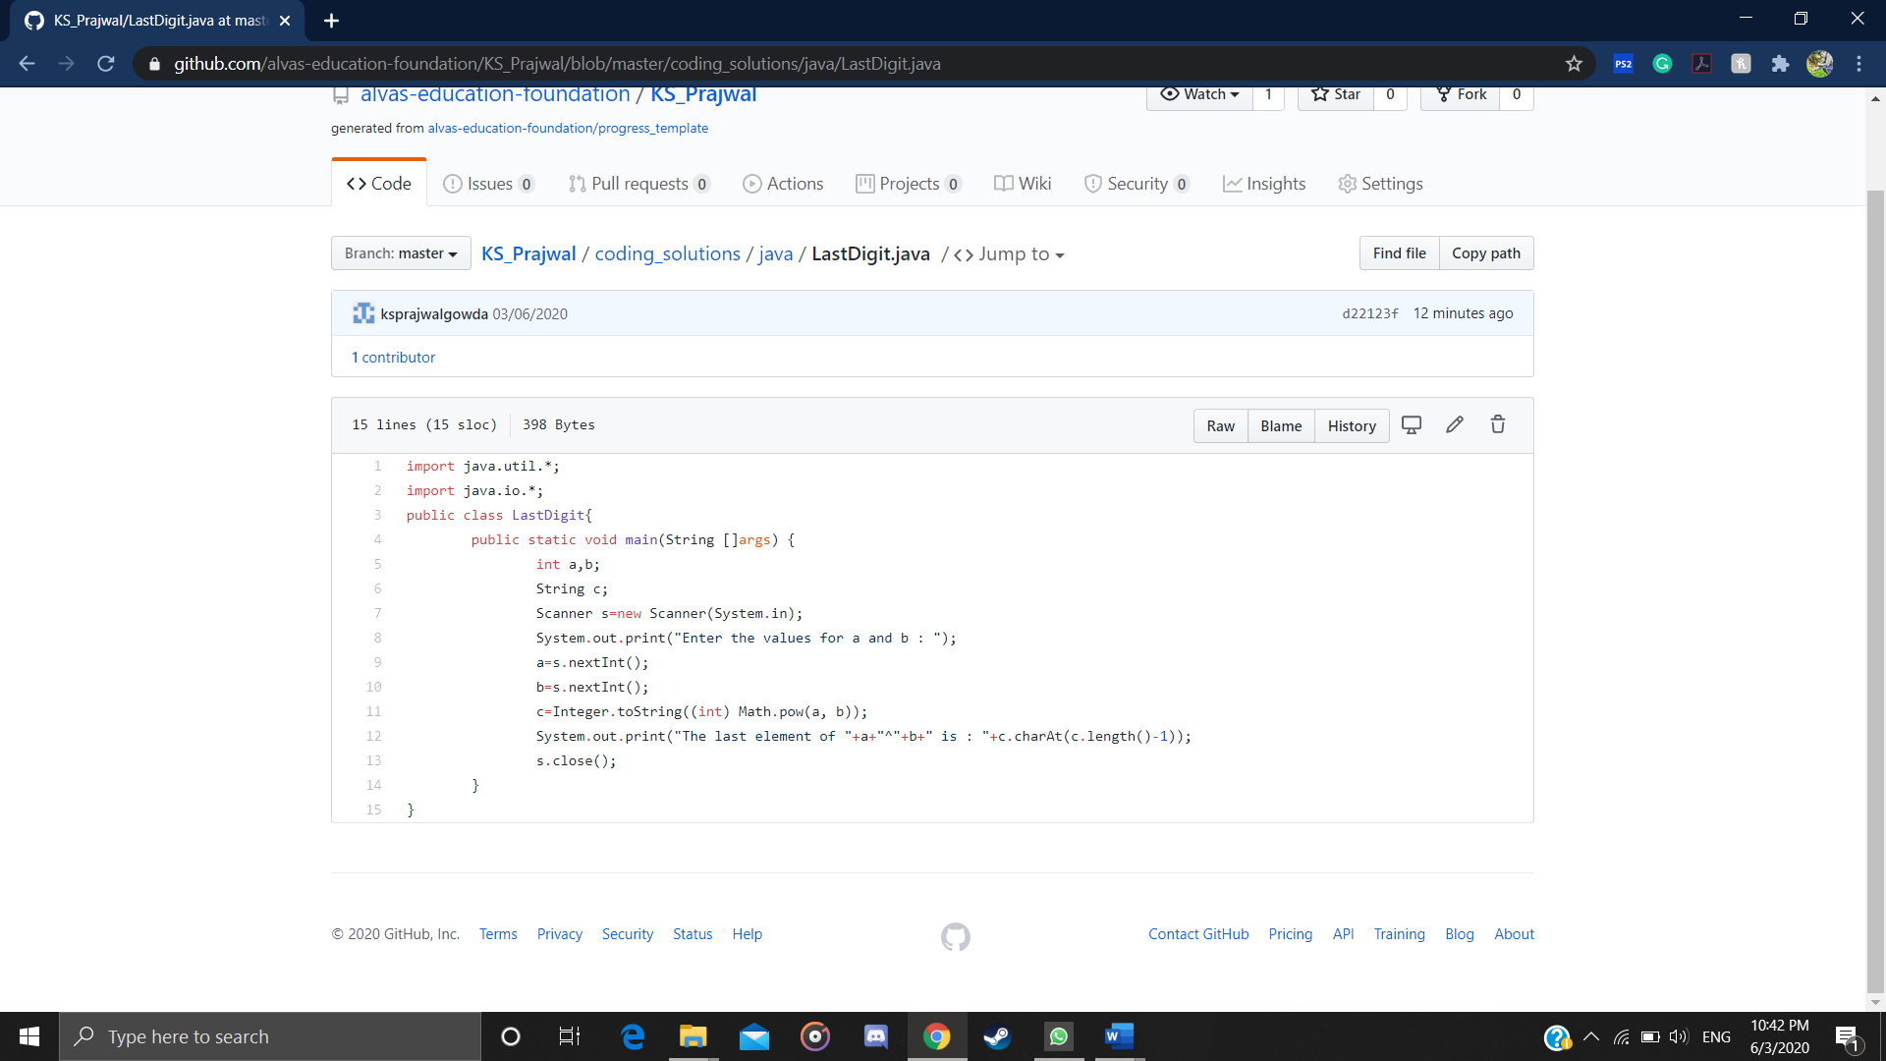

Problem 2: (using C++) Write a function that takes a two-digit number and determines if it's the largest of two possible digit swaps.

